Statistical Measures
Sleep Disorder Analysis
Preethi Sri B -23MIS0470
Yuva Krithikka S -23MIS0437
Madhumitha B -23MS0360

Review 1:
- Measuring Central Tendency(Mean,Median,Mode):
Code:
import pandas as pd

file_path = r"C:\Users\User\OneDrive\Documents\DataMining Proj\subset_reduced_dataset.xlsx"
df = pd.read_excel(file_path)

print("----- Central Tendency Measures -----")

#Mean
print("\nMean values:")
print(df.mean(numeric_only=True))

#Median
print("\nMedian values:")
print(df.median(numeric_only=True))

# Mode
print("\nMode values:")
print(df.mode(numeric_only=True).iloc[0])

Output:
----- Central Tendency Measures -----

Mean values:
Age 0.486883
Gender 0.508000
Sleep_Disorder_Type 2.055000
AHI_Score 0.514212
SaO2_Level 0.500516
Diagnosis_Confirmed 0.884000
Smoking_Habit 0.474000
Alcohol_Consumption 1.012000
Exercise_Frequency 3.438000
Caffeine_Intake 1.010000
Work_Shift 0.971000
dtype: float64

Median values:
Age 0.480519
Gender 1.000000
Sleep_Disorder_Type 3.000000
AHI_Score 0.527817
SaO2_Level 0.505613
Diagnosis_Confirmed 1.000000
Smoking_Habit 0.000000
Alcohol_Consumption 1.000000
Exercise_Frequency 3.000000
Caffeine_Intake 1.000000
Work_Shift 1.000000
dtype: float64

Mode values:
Age 0.792208
Gender 1.000000
Sleep_Disorder_Type 3.000000
AHI_Score 0.129678
SaO2_Level 0.524860
Gender 1.000000
Sleep_Disorder_Type 3.000000
AHI_Score 0.129678
SaO2_Level 0.524860
Diagnosis_Confirmed 1.000000
Smoking_Habit 0.000000
Alcohol_Consumption 2.000000
Exercise_Frequency 4.000000
Caffeine_Intake 2.000000
Work_Shift 1.000000
Name: 0, dtype: float64

- Range , Quartiles and Interquartile Range(IQR)

Code:

import pandas as pd

file_path = r"C:\Users\User\OneDrive\Documents\DataMining Proj\subset_reduced_dataset.xlsx"
df = pd.read_excel(file_path)

print("----- Range, Quartiles & IQR -----")

# Range (max - min)
print("\nRange (Max - Min):")
range_values = df.max(numeric_only=True) - df.min(numeric_only=True)
print(range_values)

# Quartiles
print("\nQuartiles (Q1, Q2, Q3):")
Q1 = df.quantile(0.25, numeric_only=True)
Q2 = df.quantile(0.50, numeric_only=True) # same as Median
Q3 = df.quantile(0.75, numeric_only=True)
print("Q1:\n", Q1)
print("Q2 (Median):\n", Q2)
print("Q3:\n", Q3)

# Interquartile Range (IQR = Q3 - Q1)
print("\nInterquartile Range (IQR):")
IQR = Q3 - Q1
print(IQR)

Output:

----- Range, Quartiles & IQR -----

Range (Max - Min):
Age 1.0
Gender 1.0
Sleep_Disorder_Type 4.0
AHI_Score 1.0
SaO2_Level 1.0
Diagnosis_Confirmed 1.0
Smoking_Habit 1.0
Alcohol_Consumption 2.0
Exercise_Frequency 7.0
Caffeine_Intake 2.0
Work_Shift 2.0
dtype: float64

Quartiles (Q1, Q2, Q3):
Q1:
Age 0.233766
Gender 0.000000
Sleep_Disorder_Type 0.000000
AHI_Score 0.268761
SaO2_Level 0.254010
Diagnosis_Confirmed 1.000000
Smoking_Habit 0.000000
Alcohol_Consumption 0.000000
Exercise_Frequency 1.000000
Caffeine_Intake 0.000000
Work_Shift 0.000000
Name: 0.25, dtype: float64
Q2 (Median):
Age 0.480519
Gender 1.000000
Sleep_Disorder_Type 3.000000
AHI_Score 0.527817
SaO2_Level 0.505613
Diagnosis_Confirmed 1.000000
Smoking_Habit 0.000000
Alcohol_Consumption 1.000000
Exercise_Frequency 3.000000
Caffeine_Intake 1.000000
Work_Shift 1.000000
Name: 0.5, dtype: float64
Q3:
Age 0.740260
Gender 1.000000
Sleep_Disorder_Type 3.000000
AHI_Score 0.762157
SaO2_Level 0.753408
Diagnosis_Confirmed 1.000000
Smoking_Habit 1.000000
Alcohol_Consumption 2.000000
Exercise_Frequency 5.000000
Caffeine_Intake 2.000000
Work_Shift 2.000000
Name: 0.75, dtype: float64

Interquartile Range (IQR):
Age 0.506494
Gender 1.000000
Sleep_Disorder_Type 3.000000
AHI_Score 0.493396
SaO2_Level 0.499399
Diagnosis_Confirmed 0.000000
Smoking_Habit 1.000000
Alcohol_Consumption 2.000000
Exercise_Frequency 4.000000
Caffeine_Intake 2.000000
Work_Shift 2.000000
dtype: float64

- Five Number Summary
Code:

import pandas as pd

# Load the reduced dataset
file_path = r"C:\Users\User\OneDrive\Documents\DataMining Proj\subset_reduced_dataset.xlsx"
df = pd.read_excel(file_path)

print("----- Five Number Summary -----")

five_num_summary = pd.DataFrame({
"Minimum": df.min(numeric_only=True),
"Q1 (25%)": df.quantile(0.25, numeric_only=True),
"Median (Q2)": df.median(numeric_only=True),
"Q3 (75%)": df.quantile(0.75, numeric_only=True),
"Maximum": df.max(numeric_only=True)
})

print(five_num_summary)

Output:

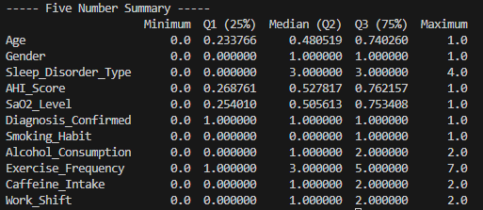

- Box Plots and Outliers:
Code:
import pandas as pd
import matplotlib.pyplot as plt

file_path = r"C:\Users\User\OneDrive\Documents\DataMining Proj\subset_reduced_dataset.xlsx"
df = pd.read_excel(file_path)

numeric_cols = df.select_dtypes(include=['number']).columns

print("----- Outlier Detection using IQR -----")
outliers_dict = {}

for col in numeric_cols:
Q1 = df[col].quantile(0.25)
Q3 = df[col].quantile(0.75)
IQR = Q3 - Q1
lower_bound = Q1 - 1.5 * IQR
upper_bound = Q3 + 1.5 * IQR

# Find outliers
outliers = df[(df[col] < lower_bound) | (df[col] > upper_bound)][col]
outliers_dict[col] = outliers.values

print(f"\n{col}:")
print(f"Lower Bound = {lower_bound}, Upper Bound = {upper_bound}")
print(f"Outliers: {outliers.values if len(outliers) > 0 else 'None'}")

# Boxplots for all numeric columns
plt.figure(figsize=(12, 6))
df[numeric_cols].boxplot()
plt.title("Boxplots with Outliers (shown as dots)")
plt.xticks(rotation=45)
plt.show()

Output:

Matplotlib is building the font cache; this may take a moment.
----- Outlier Detection using IQR -----

Age:
Lower Bound = -0.525974025974026, Upper Bound = 1.5
Outliers: None

Gender:
Lower Bound = -1.5, Upper Bound = 2.5
Outliers: None

Sleep_Disorder_Type:
Lower Bound = -4.5, Upper Bound = 7.5
Outliers: None

AHI_Score:
Lower Bound = -0.4713327996798081, Upper Bound = 1.5022513508104867
Outliers: None

SaO2_Level:
Lower Bound = -0.4950882117080991, Upper Bound = 1.5025060144346436
Outliers: None

Diagnosis_Confirmed:
Lower Bound = 1.0, Upper Bound = 1.0
Outliers: [0 0 0 0 0 0 0 0 0 0 0 0 0 0 0 0 0 0 0 0 0 0 0 0 0 0 0 0 0 0 0 0 0 0 0 0 0
0 0 0 0 0 0 0 0 0 0 0 0 0 0 0 0 0 0 0 0 0 0 0 0 0 0 0 0 0 0 0 0 0 0 0 0 0
0 0 0 0 0 0 0 0 0 0 0 0 0 0 0 0 0 0 0 0 0 0 0 0 0 0 0 0 0 0 0 0 0 0 0 0 0
0 0 0 0 0]

Smoking_Habit:
Lower Bound = -1.5, Upper Bound = 2.5
Outliers: None

Alcohol_Consumption:
Alcohol_Consumption:
Lower Bound = -3.0, Upper Bound = 5.0
Outliers: None

Exercise_Frequency:
Lower Bound = -5.0, Upper Bound = 11.0
Outliers: None

Caffeine_Intake:
Lower Bound = -3.0, Upper Bound = 5.0
Outliers: None

Work_Shift:
Lower Bound = -3.0, Upper Bound = 5.0
Outliers: None

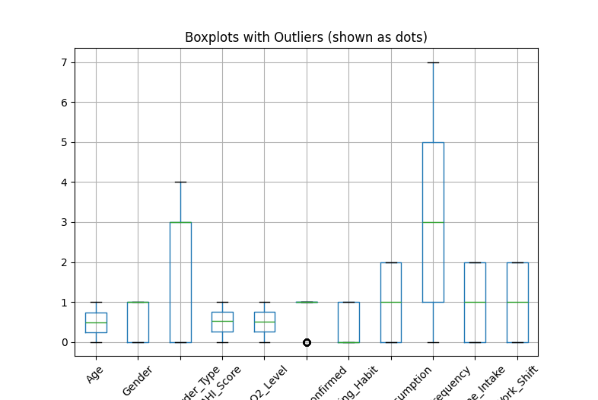

- Variance and Standard Deviation
Code:
import pandas as pd

file_path = r"C:\Users\User\OneDrive\Documents\DataMining Proj\subset_reduced_dataset.xlsx"
df = pd.read_excel(file_path)

df_AF = df.iloc[:, 0:6]

print("----- Variance -----")
print(df_AF.var(numeric_only=True))

print("\n----- Standard Deviation -----")
print(df_AF.std(numeric_only=True))

Output:
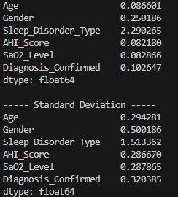

- Covariance and correlation
Code:
import pandas as pd

file_path = r"C:\Users\User\OneDrive\Documents\DataMining Proj\subset_reduced_dataset.xlsx"
df = pd.read_excel(file_path)

df_AF = df.iloc[:, 0:6]

print("----- Covariance Matrix -----")
print(df_AF.cov())

print("\n----- Correlation Matrix -----")
print(df_AF.corr())

Output:
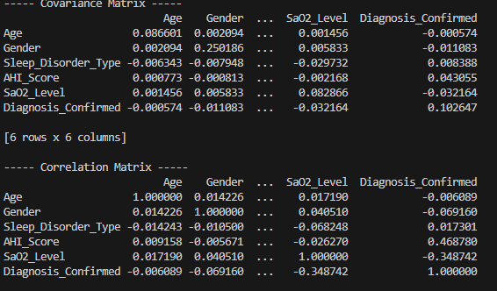

- Chi-Square test
Code:
import pandas as pd
from scipy.stats import chi2_contingency

file_path = r"C:\Users\User\OneDrive\Documents\DataMining Proj\subset_reduced_dataset.xlsx"
df = pd.read_excel(file_path)

# Assuming A and B are categorical
contingency_table = pd.crosstab(df.iloc[:,0], df.iloc[:,1])
chi2, p, dof, expected = chi2_contingency(contingency_table)

print("Chi-Square Test Results:")
print("Chi2 Value:", chi2)
print("p-value:", p)
print("Degrees of Freedom:", dof)
print("Expected Frequencies:\n", expected)

Output:
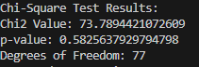

- Quantile plot
Code:

import pandas as pd
import numpy as np
import matplotlib.pyplot as plt

# Load dataset
file_path = r"C:\Users\User\OneDrive\Documents\DataMining Proj\subset_reduced_dataset.xlsx"
df = pd.read_excel(file_path)

# Select only columns A–F
df_selected = df.iloc[:, 0:6]

# Generate quantile plots
for column in df_selected.columns:
data = df_selected[column].dropna()
quantiles = np.linspace(0, 1, len(data))
sorted_data = np.sort(data)

plt.figure(figsize=(8, 5))
plt.plot(quantiles, sorted_data, 'o', markersize=3)
plt.title(f"Quantile Plot for {column}")
plt.xlabel("Quantiles (0 to 1)")
plt.ylabel(column)
plt.grid(True)
plt.show()

Output:
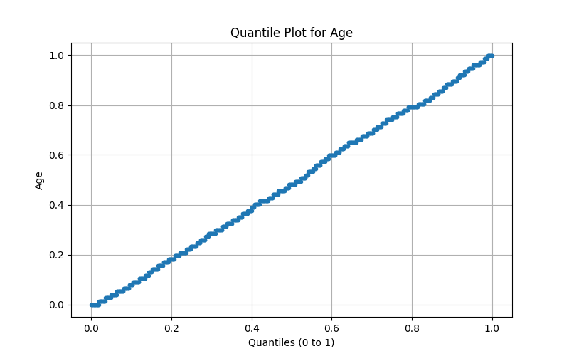
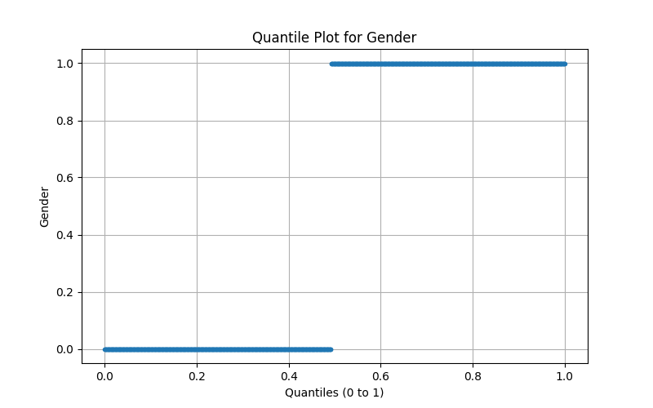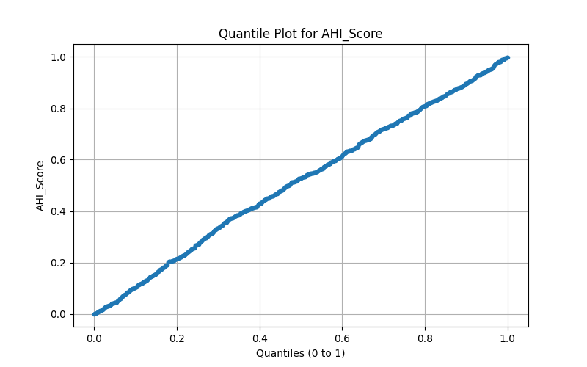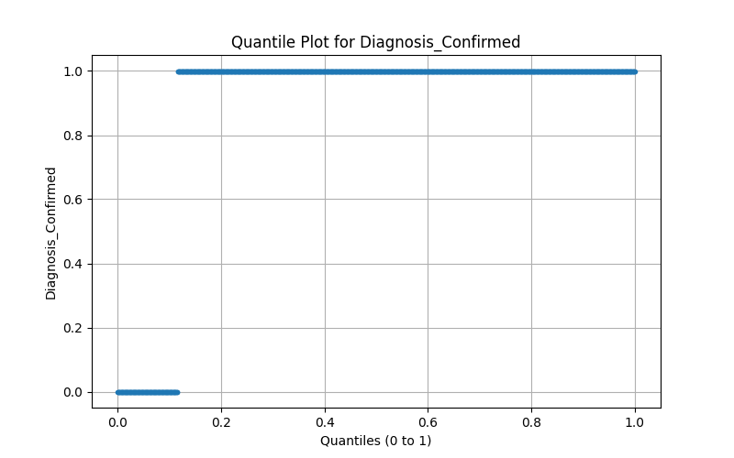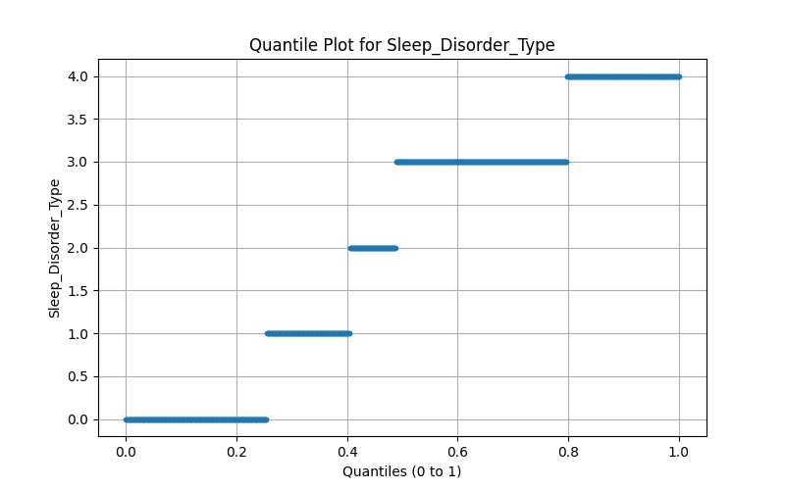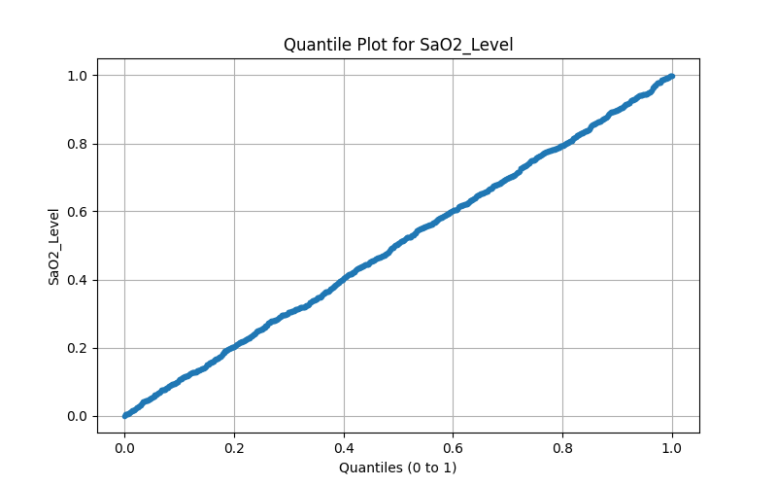

- Q-Q Plot
Code:
import pandas as pd
import matplotlib.pyplot as plt
import scipy.stats as stats

file_path = r"C:\Users\User\OneDrive\Documents\DataMining Proj\subset_reduced_dataset.xlsx"
df = pd.read_excel(file_path)

df_AF = df.iloc[:, 0:6]

for col in df_AF.columns:
stats.probplot(df_AF[col], dist="norm", plot=plt)
plt.title(f"Q–Q Plot for {col}")
plt.show()

Output:
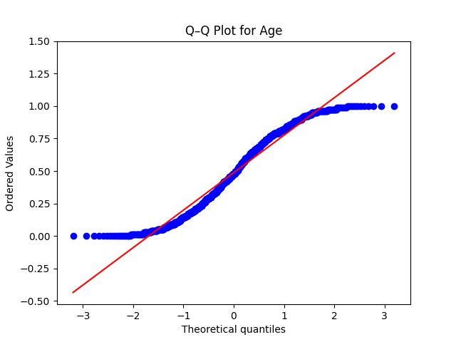
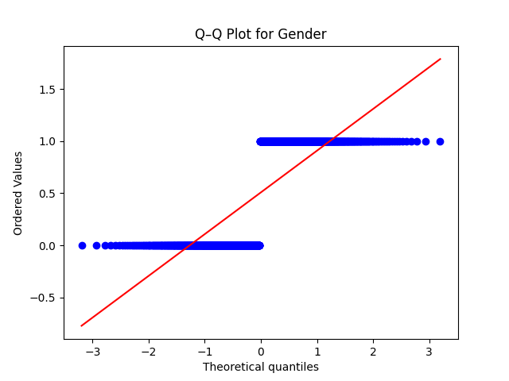
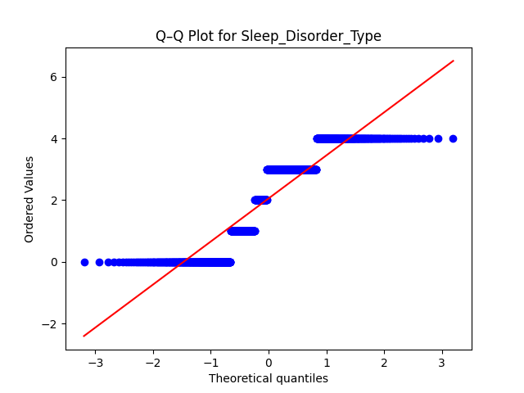
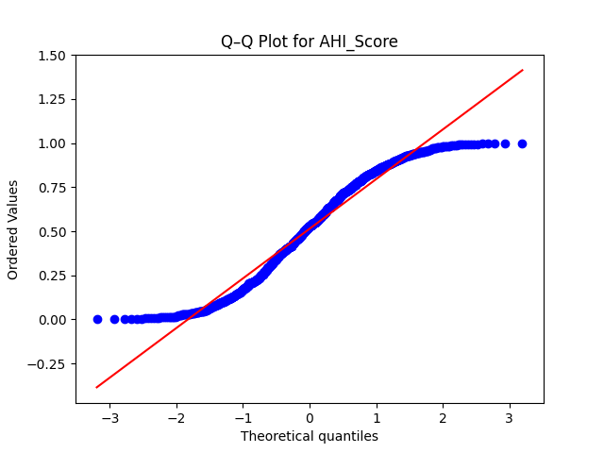
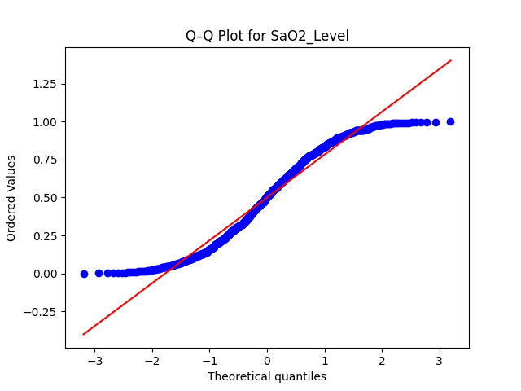
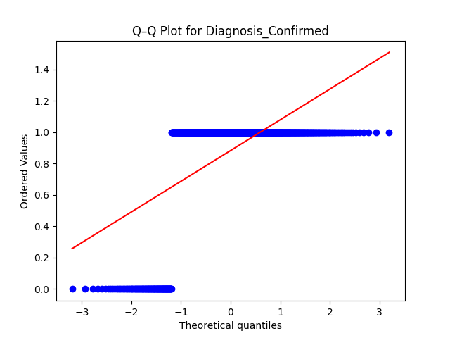

- Histogram
Code:
import pandas as pd
import matplotlib.pyplot as plt

file_path = r"C:\Users\User\OneDrive\Documents\DataMining Proj\subset_reduced_dataset.xlsx"
df = pd.read_excel(file_path)

df_AF = df.iloc[:, 0:6]

df_AF.hist(figsize=(12, 8), bins=15)
plt.suptitle("Histograms of A–F Columns")
plt.show()

Output:
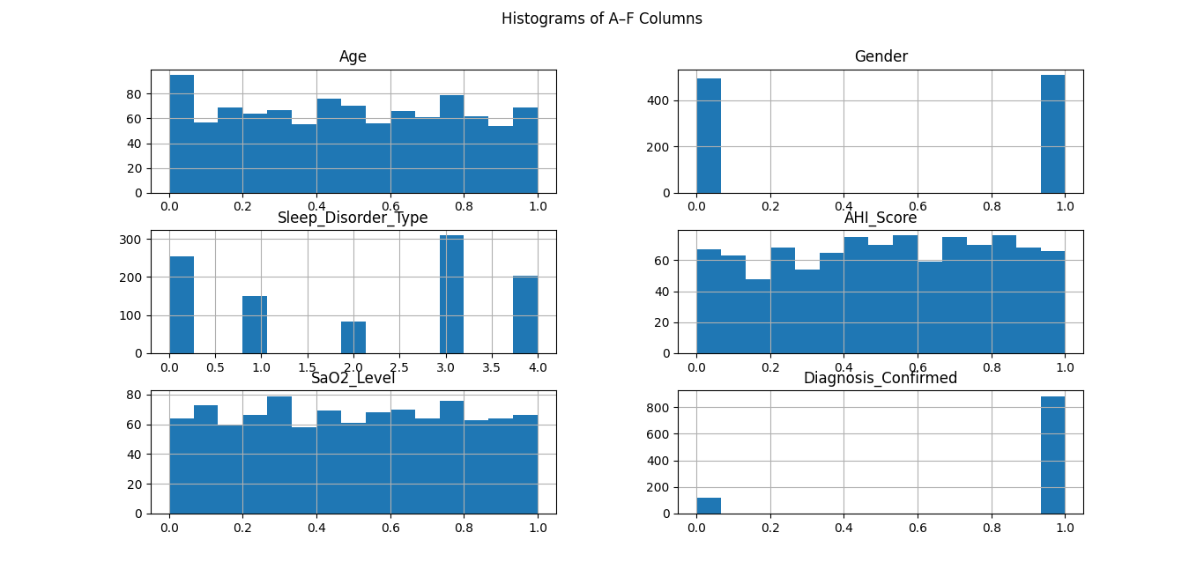

- Scatter Plot
Code:
import pandas as pd
import matplotlib.pyplot as plt

file_path = r"C:\Users\User\OneDrive\Documents\DataMining Proj\subset_reduced_dataset.xlsx"
df = pd.read_excel(file_path)

df_AF = df.iloc[:, 0:6]

pd.plotting.scatter_matrix(df_AF, figsize=(12, 8), diagonal='hist')
plt.suptitle("Scatter Matrix Plot")
plt.show()

Output:
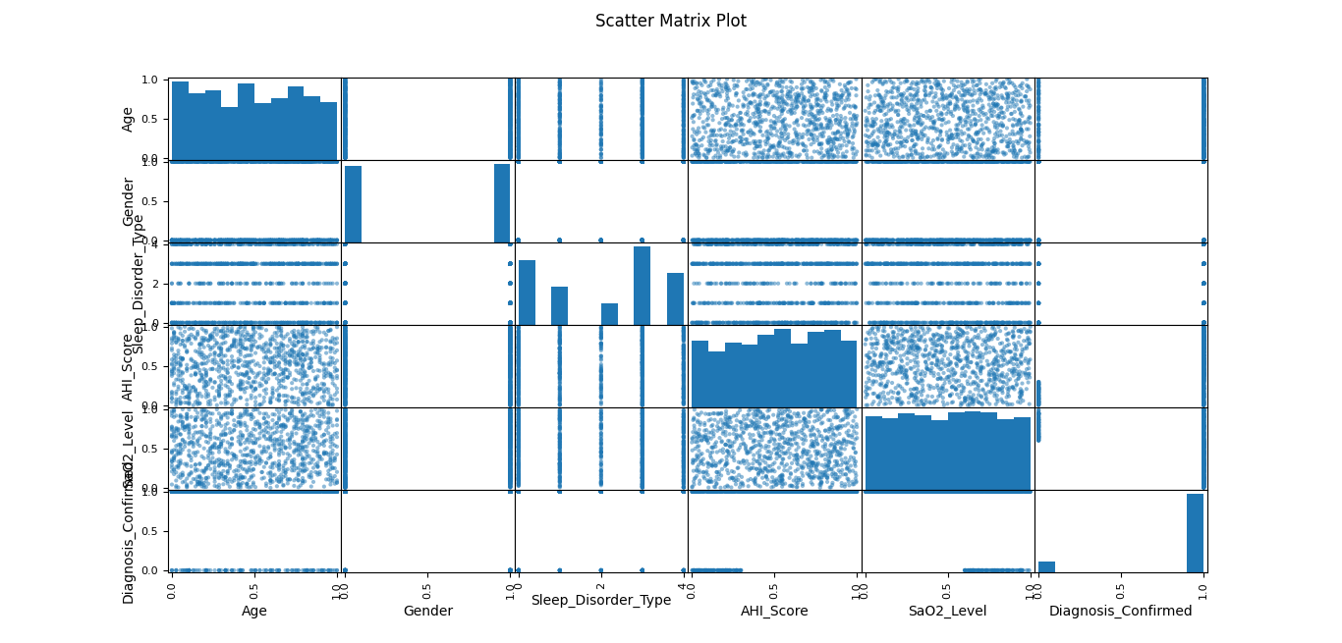

- PEARSON CORRELATION COEFFICIENT and COSINE SIMILARITY
Code:
import pandas as pd
from sklearn.metrics.pairwise import cosine_similarity

file_path = r"C:\Users\User\OneDrive\Documents\DataMining Proj\subset_reduced_dataset.xlsx"
df = pd.read_excel(file_path)

df_AF = df.iloc[:, 0:6]

print("----- Pearson Correlation -----")
print(df_AF.corr(method='pearson'))

print("\n----- Cosine Similarity -----")
cos_sim = cosine_similarity(df_AF.T) # Transposed for column-wise similarity
cosine_df = pd.DataFrame(cos_sim, index=df_AF.columns, columns=df_AF.columns)
print(cosine_df)

Output:
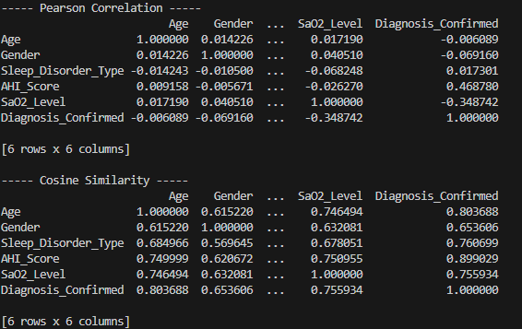

- MINKOWSHKI DISTANCE
Code:
import pandas as pd
from scipy.spatial import distance

file_path = r"C:\Users\User\OneDrive\Documents\DataMining Proj\subset_reduced_dataset.xlsx"
df = pd.read_excel(file_path)

df_AF = df.iloc[:, 0:6]

row1 = df_AF.iloc[0]
row2 = df_AF.iloc[1]

minkowski_dist = distance.minkowski(row1, row2, p=3)
print("Minkowski Distance (p=3) between Row1 & Row2:", minkowski_dist)

Output:

- DISTANCE MEASURES FOR DISSIMILARITY (EUCLIDEAN / MANHATTAN / SUPREMUM)
Code:
import pandas as pd
from scipy.spatial import distance

file_path = r"C:\Users\User\OneDrive\Documents\DataMining Proj\subset_reduced_dataset.xlsx"
df = pd.read_excel(file_path)

df_AF = df.iloc[:, 0:6]

row1 = df_AF.iloc[0]
row2 = df_AF.iloc[1]

euclidean = distance.euclidean(row1, row2)
manhattan = distance.cityblock(row1, row2)
supremum = distance.chebyshev(row1, row2)

print("Euclidean Distance:", euclidean)
print("Manhattan Distance:", manhattan)
print("Supremum (Chebyshev) Distance:", supremum)

Output:
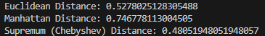

- DISSIMILARITY MATRIX
Code:
import pandas as pd
from scipy.spatial.distance import pdist, squareform

file_path = r"C:\Users\User\OneDrive\Documents\DataMining Proj\subset_reduced_dataset.xlsx"
df = pd.read_excel(file_path)

df_AF = df.iloc[:, 0:6]

# Euclidean Dissimilarity Matrix
euclidean_matrix = squareform(pdist(df_AF, metric='euclidean'))
print("Euclidean Dissimilarity Matrix:\n", euclidean_matrix)

# Manhattan Dissimilarity Matrix
manhattan_matrix = squareform(pdist(df_AF, metric='cityblock'))
print("\nManhattan Dissimilarity Matrix:\n", manhattan_matrix)

# Supremum (Chebyshev) Dissimilarity Matrix
supremum_matrix = squareform(pdist(df_AF, metric='chebyshev'))
print("\nSupremum (Chebyshev) Dissimilarity Matrix:\n", supremum_matrix)

Output:
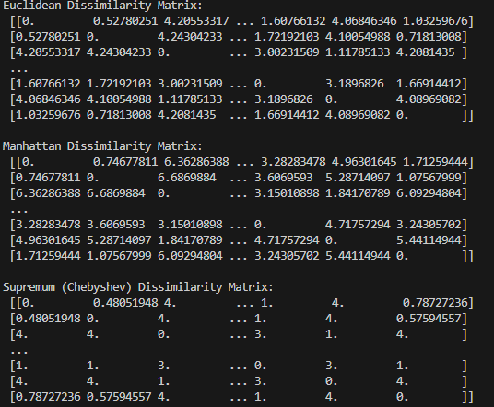

- SIMMILARITY AND DISSIMILARITY FOR(ORDINAL,NOMINAL,BINARY) .
Code:
import pandas as pd
import numpy as np
from scipy.spatial.distance import pdist, squareform
from sklearn.preprocessing import LabelEncoder

file_path = r"C:\Users\User\OneDrive\Documents\DataMining Proj\subset_reduced_dataset.xlsx"
df = pd.read_excel(file_path)

df_selected = df.iloc[:, 0:6]

df_nominal = df_selected.astype(str).apply(LabelEncoder().fit_transform)
def simple_matching(u, v):
return np.sum(u != v) / len(u)
nominal_dist = squareform(pdist(df_nominal.values, metric=simple_matching))
print("\nNominal/Categorical (Simple Matching):")
print(pd.DataFrame(nominal_dist).round(2))

df_binary = df_selected.applymap(lambda v: 1 if v > df_selected.median().median() else 0)
binary_dist = squareform(pdist(df_binary.values, metric="jaccard"))
print("\nBinary (Jaccard Distance):")
print(pd.DataFrame(binary_dist).round(2))

df_ordinal = df_selected.rank(method="average") / df_selected.rank(method="average").max()
ordinal_dist = squareform(pdist(df_ordinal.values, metric="euclidean"))
print("\nOrdinal (Euclidean on Ranks):")
print(pd.DataFrame(ordinal_dist).round(2))

Output:
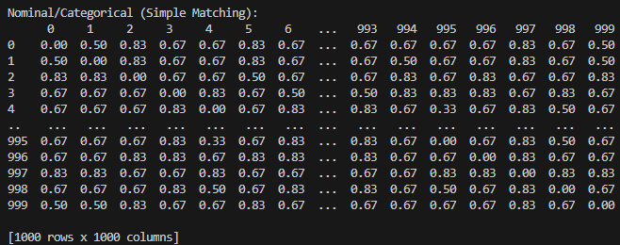

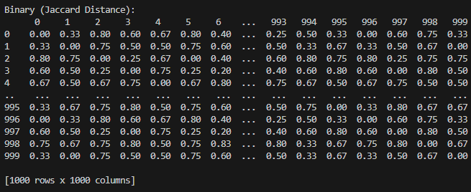

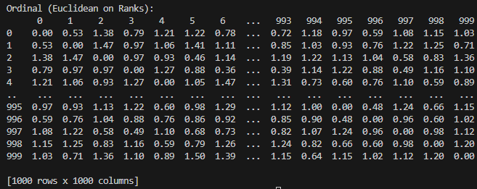

- MIXED ATTRIBUTES
Code:
import pandas as pd
import gower
import numpy as np

file_path = "subset_reduced_dataset.xlsx"
df = pd.read_excel(file_path)
data = df.iloc[:, 0:6]

# Compute Gower distance (dissimilarity) matrix
gower_dist = gower.gower_matrix(data)

# Round for better readability
gower_dist = np.round(gower_dist, 2)
print(pd.DataFrame(gower_dist))

Output:
